**JAVASCRIPT Basics**

**Inbuilt Objects**

* Math:
  + Giving some mathematic related function and constant.
  + Like Math.pow(), Math.max() etc.

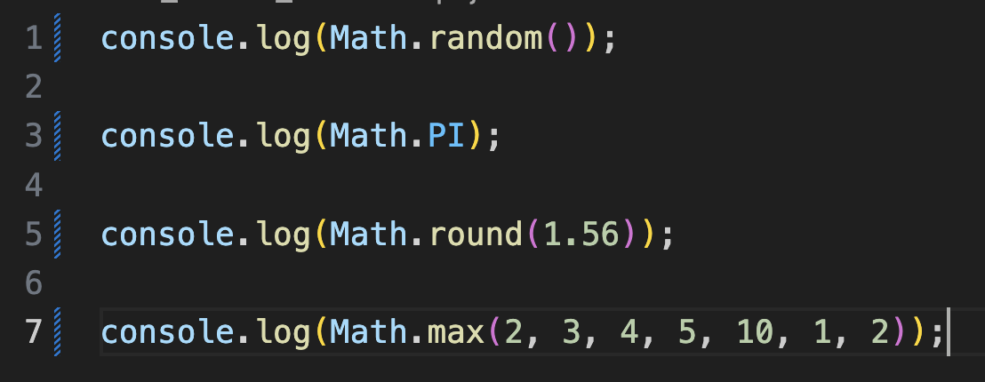

* String:
  + String can be primitive and can also be object.
  + If we are using string as normal for output purpose then it does not have any properties.
  + But if we are using it as object then it has these kinds of properties.

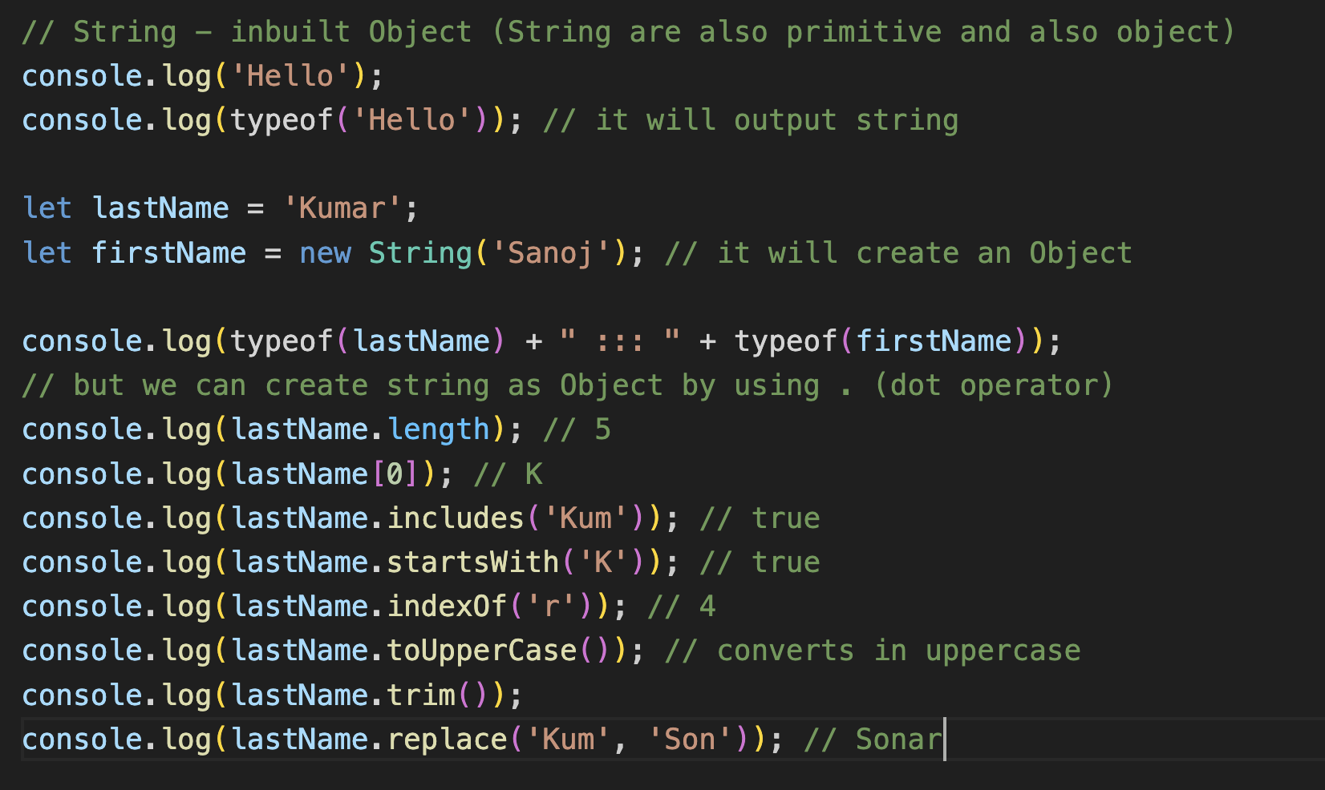

* Template Literal:
  + If we want to create some kind of paragraph type of things.
  + If we want to add dynamically numbers from input while forming the string there, we can use template literal.
  + If we want to use single quote there, we need to use some kind of \’ or Escape Sequence.
  + We can do this using ` `. (button just below the escape button).

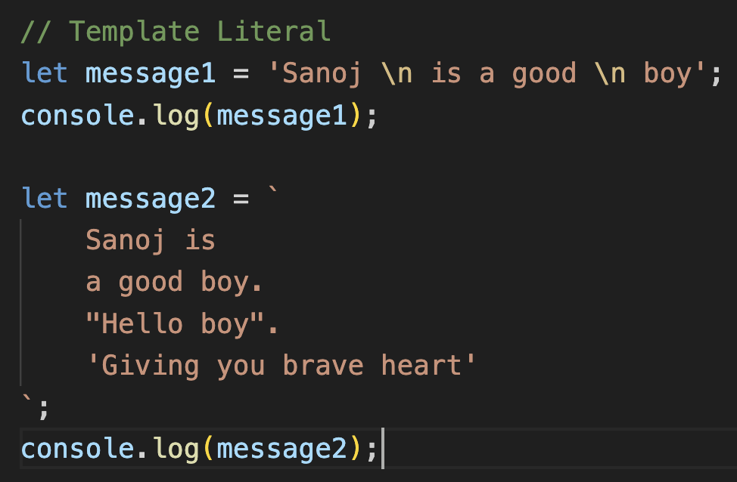

* Date and Time
  + Read at MDN Docs.

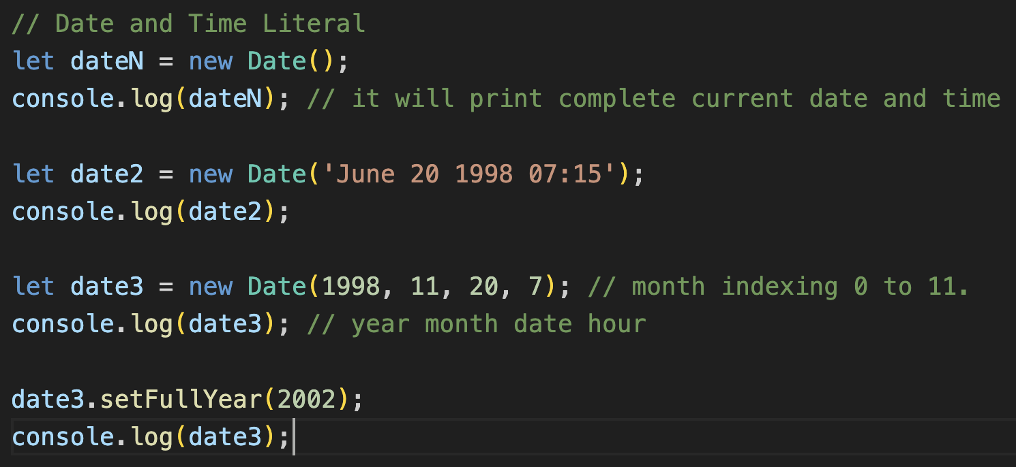

**Arrays: Collection of items (same or different)**

* Adding New Elements:
  + Indexing will be given from 0 to length - 1.
  + Insertion can be done using three ways: start, end, middle

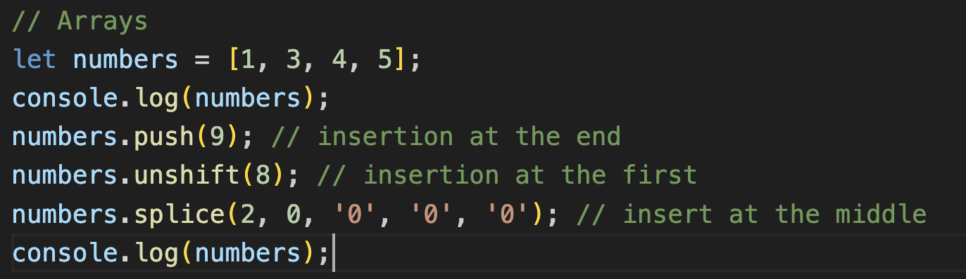

* Finding Elements:
  + For finding out the elements in array or in objects/references.

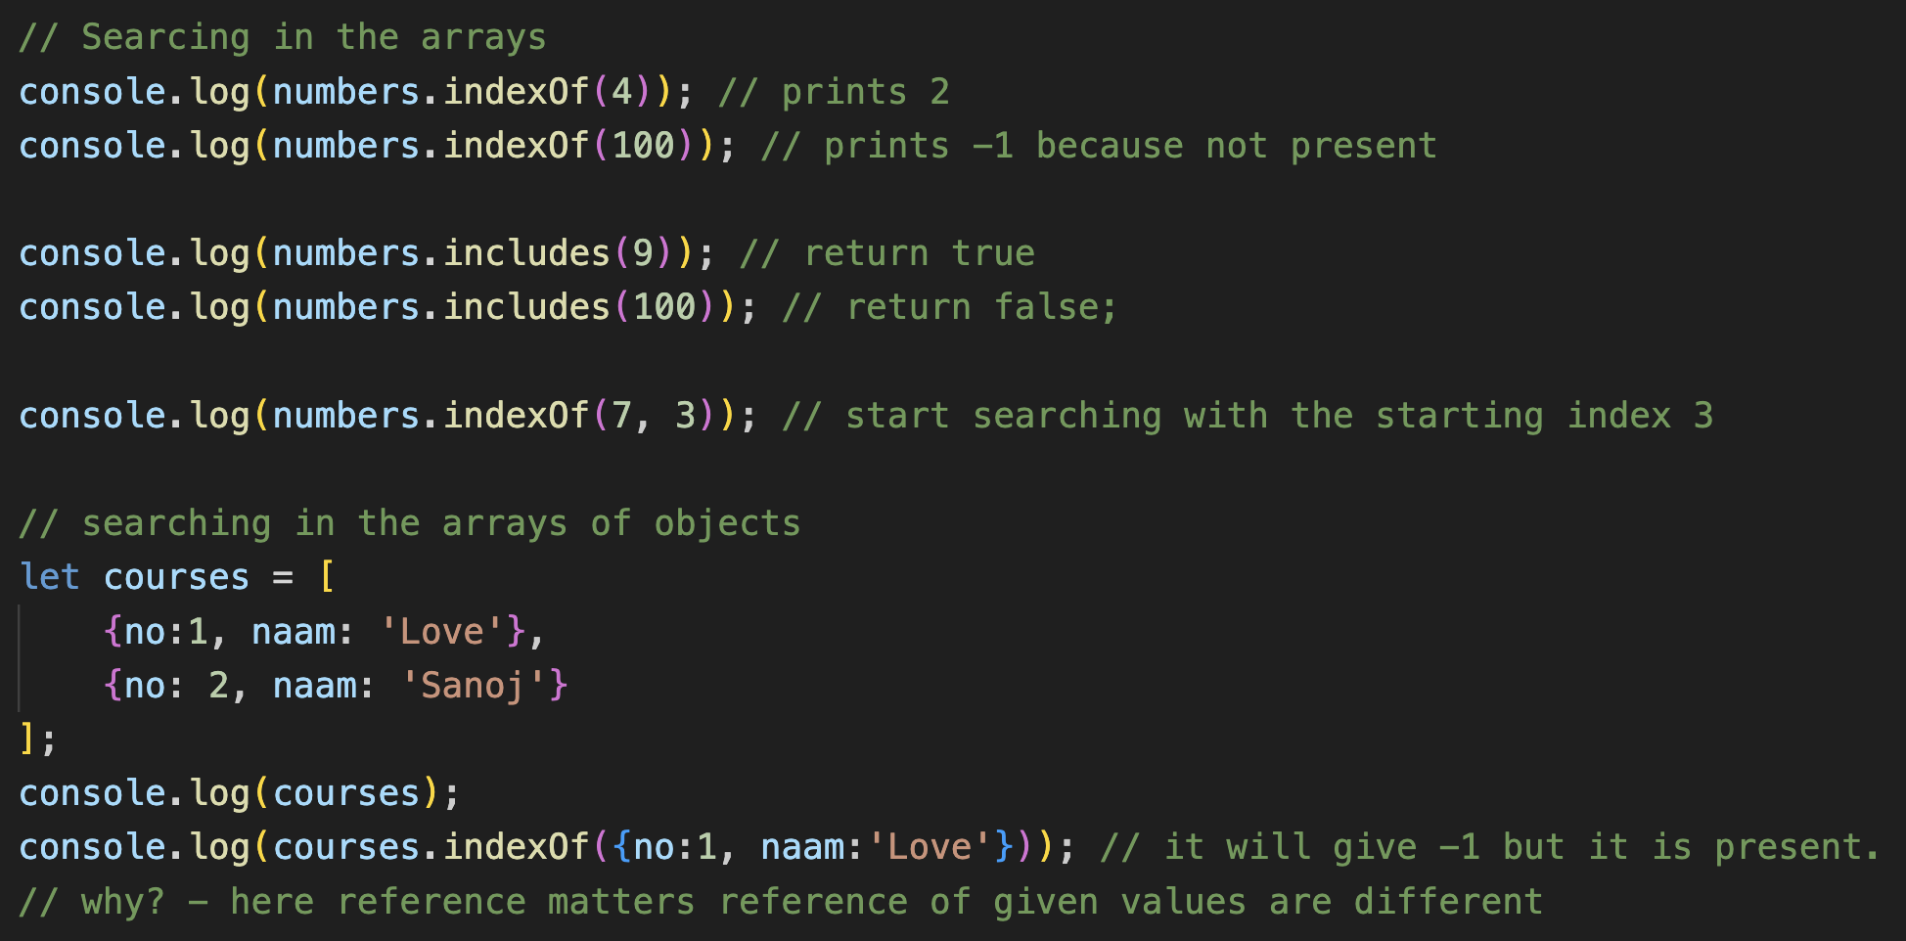

* + Now to search in array of object/reference we will use callback function
  + Callback functions is a function passed into other functions as an argument, which is then invoked inside the outer function to complete some kind of routine or actions.

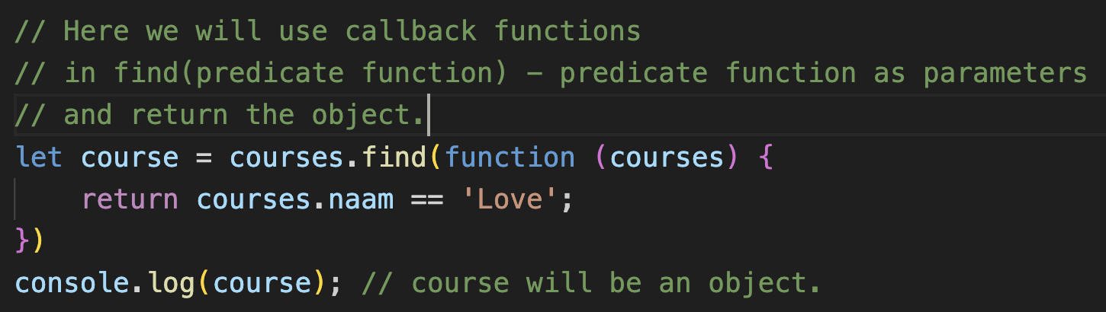

* + This can be done using arrow functions also.

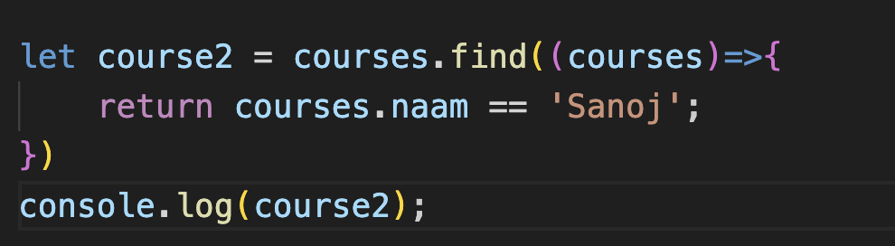

* Removing Element:
  + Removing the elements from end, begin, middle.

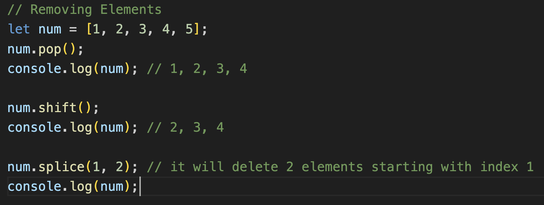

* Emptying the array:
  + To delete all the elements of the arrays

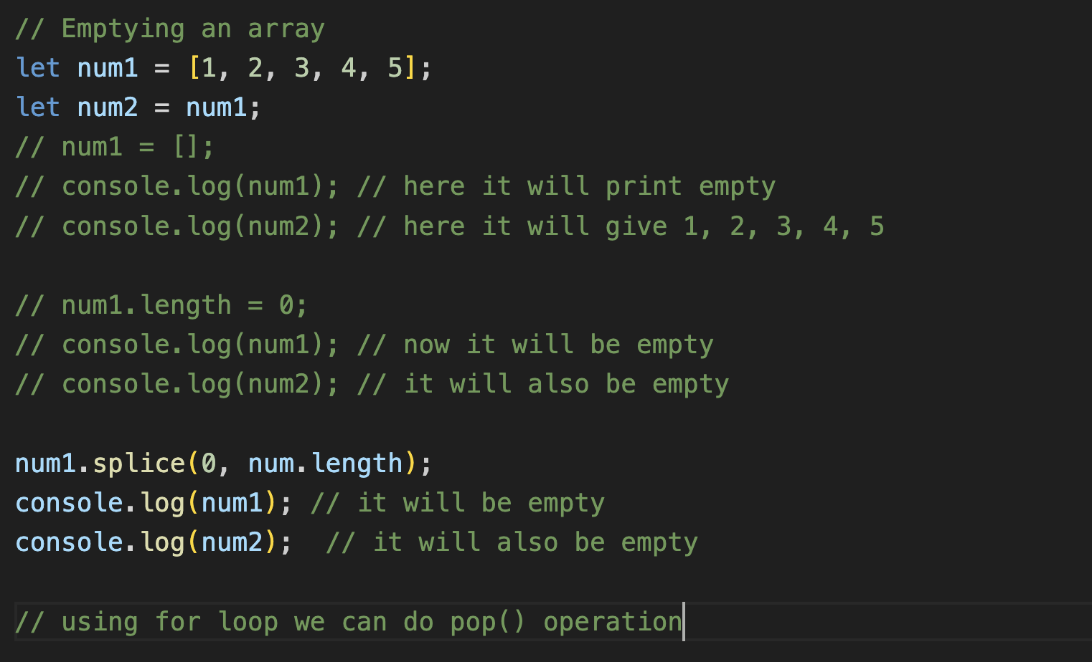

* Combining and slicing the arrays:
  + Combining the elements of two arrays into one using concat() method.

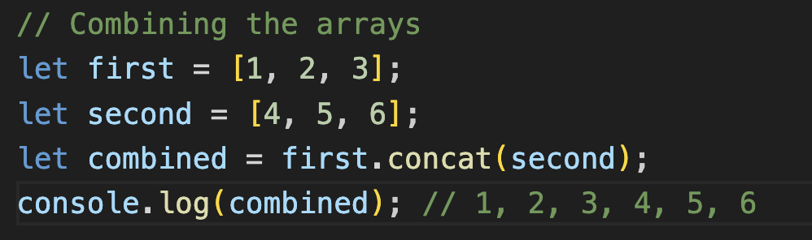

* + Slicing is done when we want to delete some array of the array element and wants to store in new array.



* Spread Operator:
  + It is also used to concatenate arrays and objects.

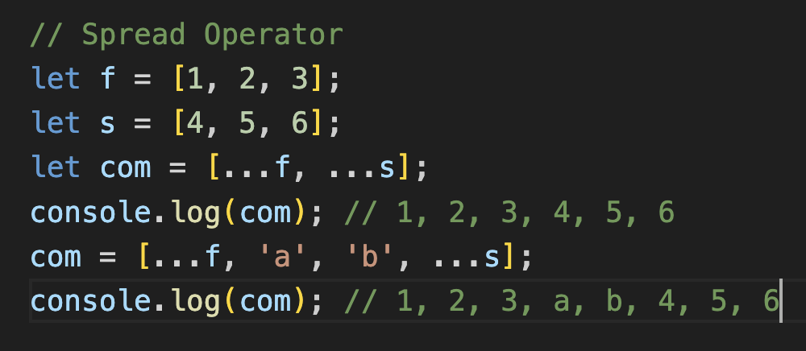

* Iterating an Array:
  + Iterate the arrays using for loop and much more

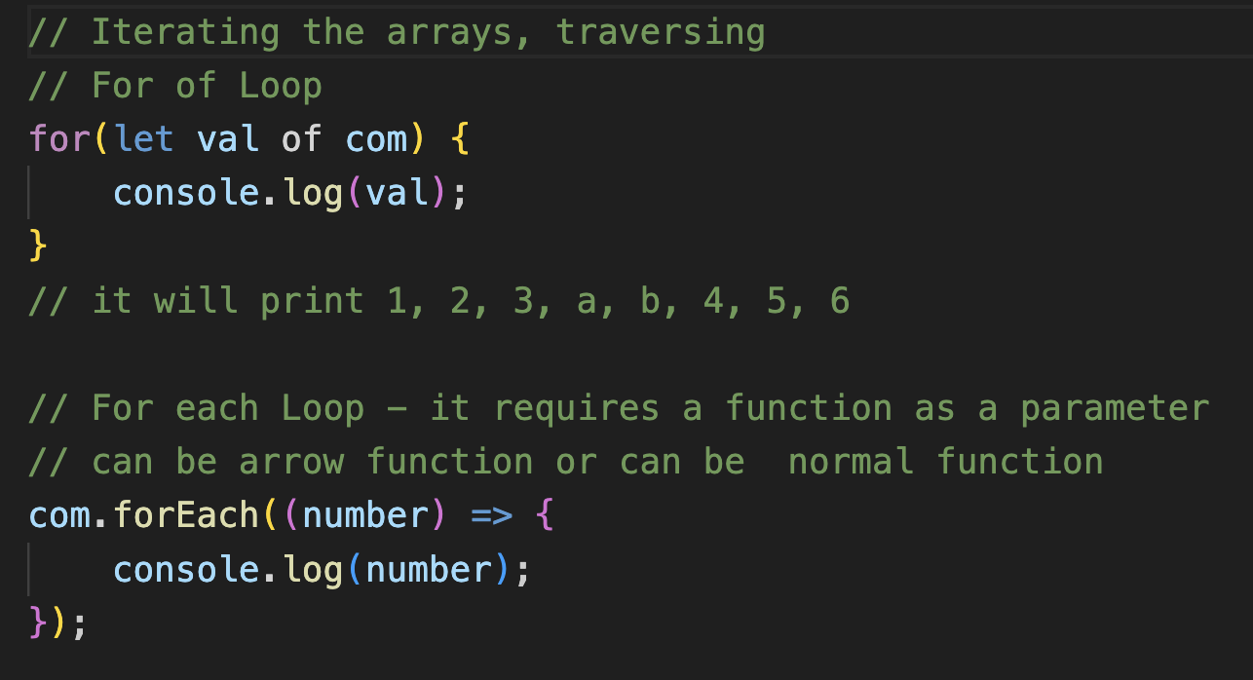

* Joining the Arrays:
  + Join accordingly via given condition using join().

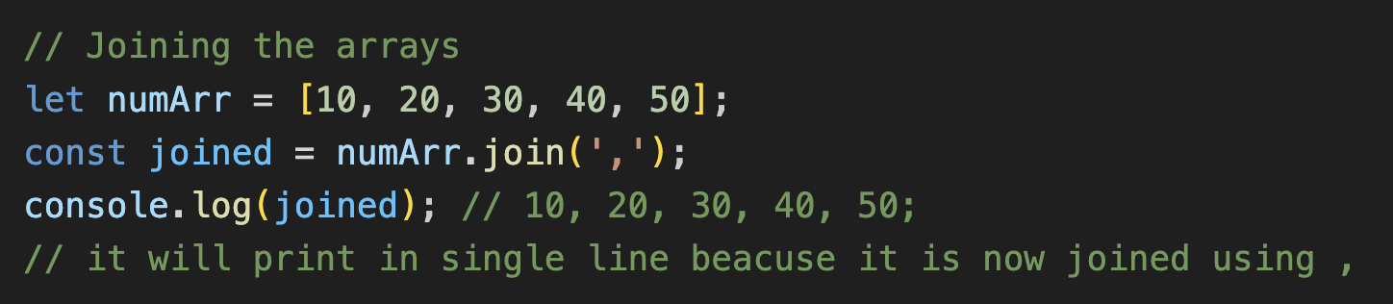

* Splitting Elements:
  + Splitting the array acc to given condition using split().

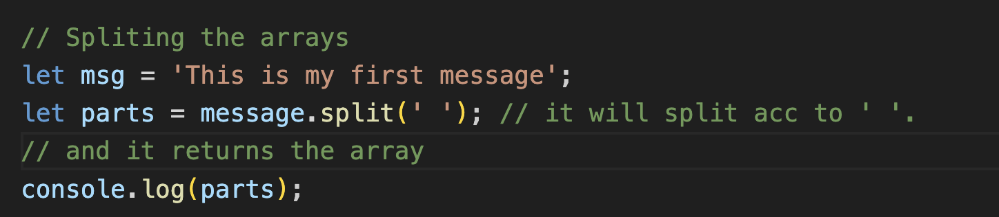

* Sorting arrays:
  + Sort the arrays in ascending / descending or in some order using sort().
  + It can be sort in any order according to our use we can do this via sending the function as a parameter to the sort function.

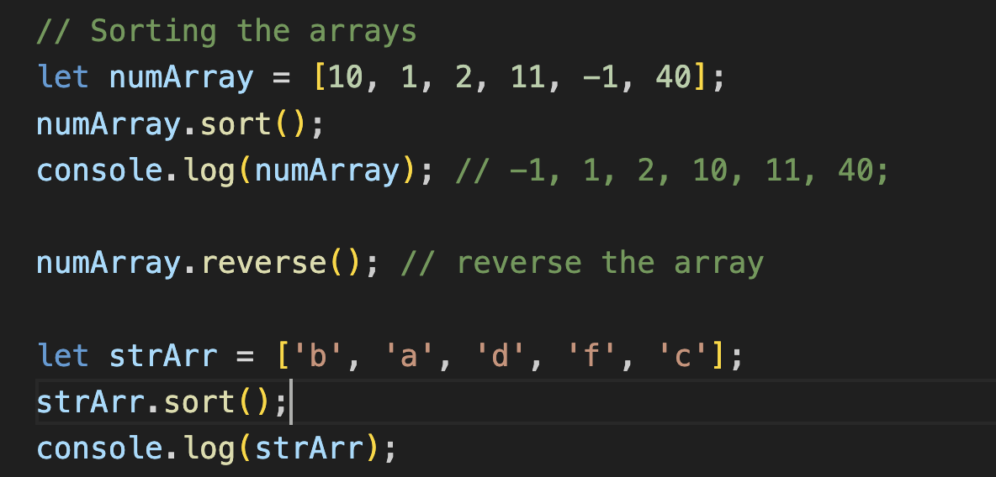

* Filtering Arrays:
  + Filter the arrays according to some condition using filter().
  + It requires another function as a parameter which tell how to filter the array elements.

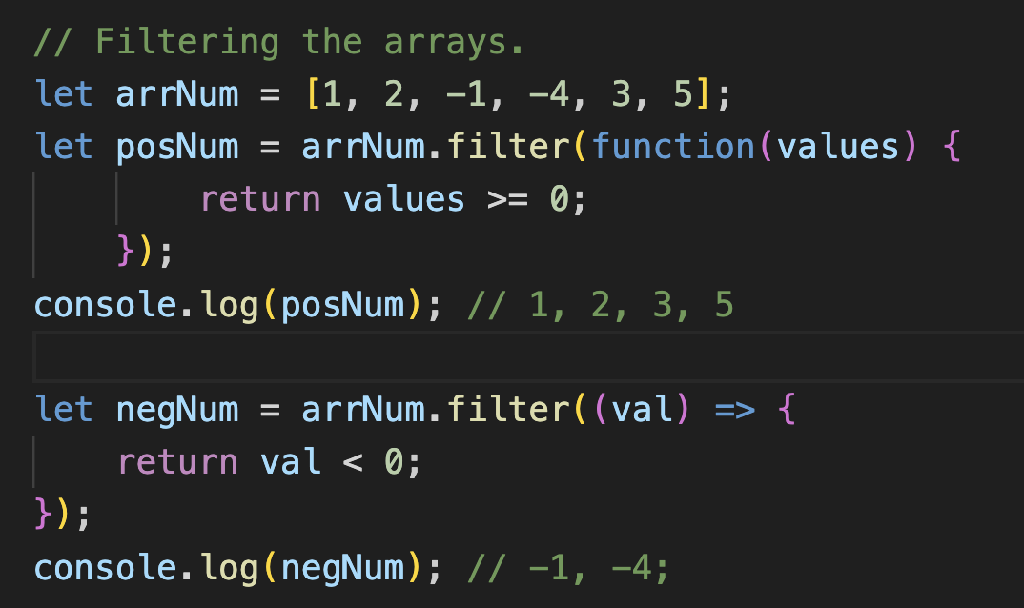

* Mapping in Arrays:
  + Maps each element of the array with something else using map().
  + It requires another function as a parameter which tell how to map or which to map.

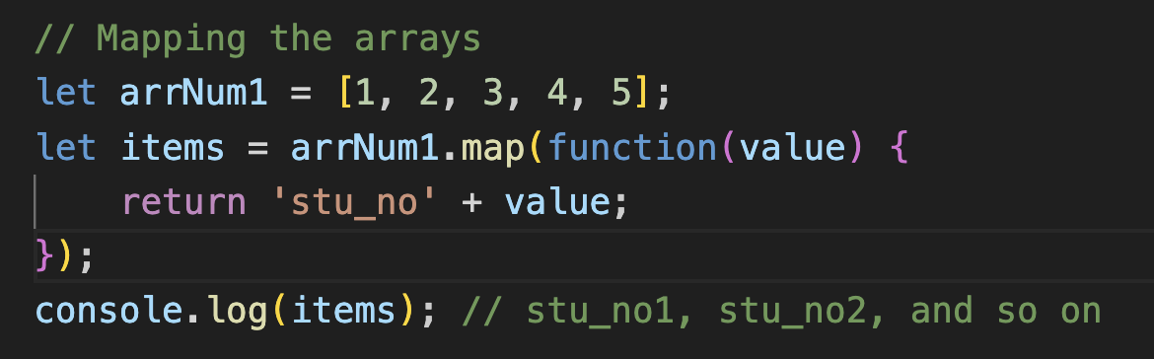

* Mapping with objects:
  + To map objects using some condition.
  + Here we can also use function chaining.

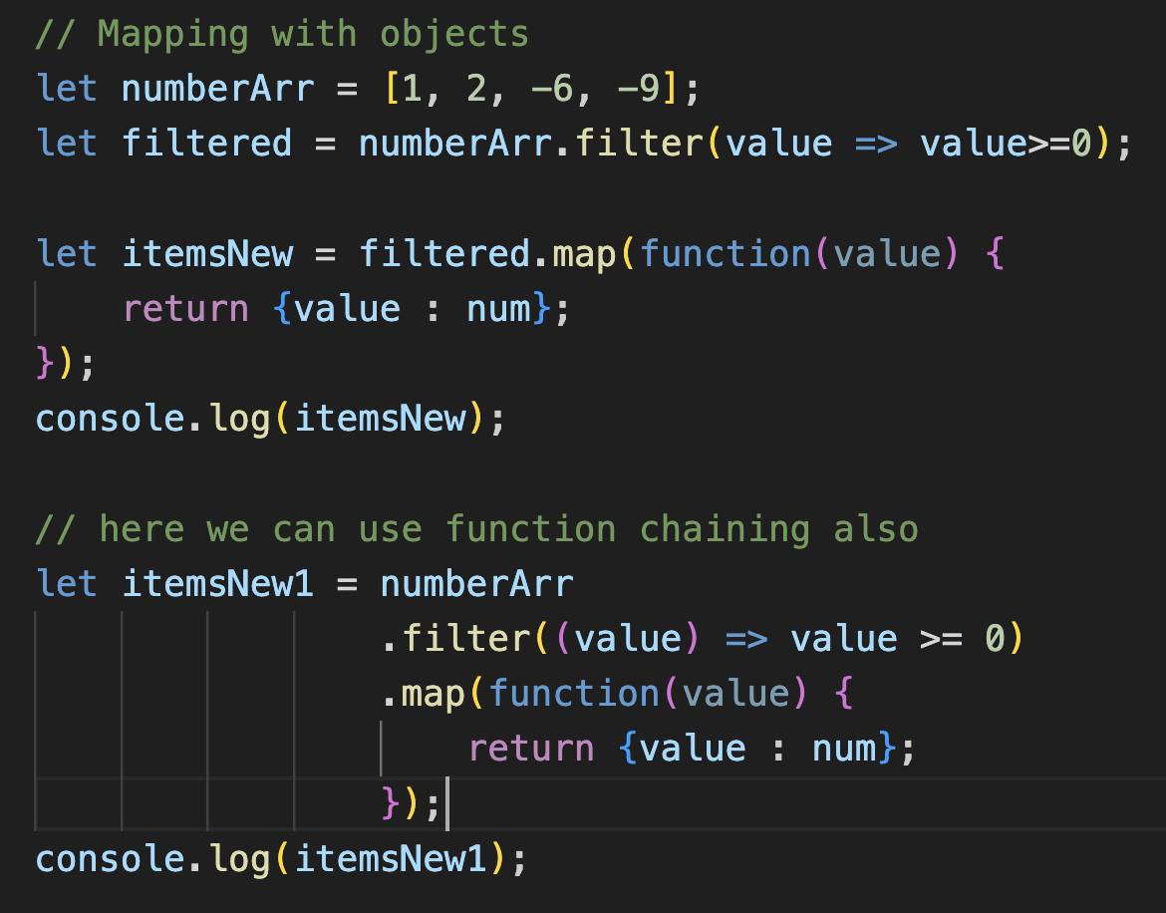

* Reducing an Array:
  + If we want to convert the array to any other variable or any kind of thing there we can use reduce.
  + Using callback function.
  + Arr.reduce(callBackFunction, value);
  + Here callbackfunction will act as accumulator and value is acting as currentValue which will be pointing to array elements.
  + 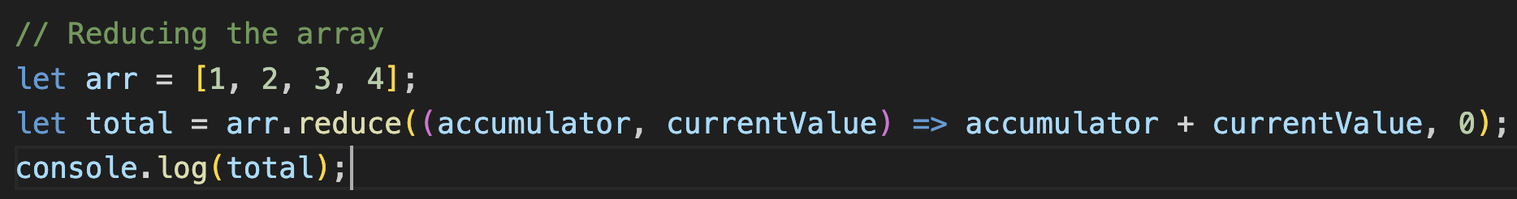
  + Here accumulator is getting sum + currentValue and 0 is basically initializing the accumulator with value = 0.